

Standard Operating Procedure for the Operation and Management
of the Ideal Health Facility Web-based Information System

October 2022



This standard operating procedure sets out the operation and management of the Ideal Health Facility web-based information system located at https://www.idealhealthfacility.org.za/ .

Revision of the SOP is done when:
- a new service provider is appointed/contract is renewed
- additional modules are added
- functionality of modules is changed

Summary of SOP version controls:
- 1st Publication: April 2018
- 2nd Publication: December 2019
- 3rd Publication: October 2022

Ms JR Hunter
Deputy Director General: Primary Health Care
Date: 18/10/2022

TABLE OF CONTENT
1. Introduction 3
2. Service Level Agreement 4
3. System Environment 4
3.1 PHP 4
3.2 Database connectivity 4
3.3 Other enabled PHP components 4
3.4 Client side components 5
3.5 The Framework 5
4. Server Specification 6
4.1 Hardware 6
4.2 Network 6
4.3 Software 6
5. Scalability 6
5.1 Web Server 6
5.2 Database 6
5.3 Content 7
5.4 Caching 7
5.5 Additional Security 7
6. Users of the information system 7
7. Functions of the information system 7
7.1 Web-based modules 7
7.2 Offline module 9
7.3 Mobile application 10
8. User account functionality 10
9. Roles and permissions for user accounts 12
10. Maintenance and security of user accounts 12
11. Information system support to staff 13
12. System support and change requests from NDoH to developers 14
13. Back-up procedure 15
14. Intellectual Property 15
15. Confidentiality of data 16

LIST OF TABLES
Table 1: Roles and functions of user accounts 12

LIST OF FIGURES
Figure 1: Upload of user account form 10
Figure 2: User account list and Audit log report 11
Figure 3: Report drop-down for Invalid Login Attempts 13
Figure 4: Generate Invalid Login Attempts report 13
Figure 5: Screenshot of support desk 14
Figure 6: Example of a worklog 14

LIST OF ANNEXURES
Annexure A: Ideal Health Facility - User Registration Form 17

- Introduction

The Ideal Health Facility (IHF) web-based information system is located at https://www.idealhealthfacility.org.za/

The Ideal Clinic Realisation and Maintenance (ICRM) programme was initiated by the National Department of Health (NDoH) in July 2013 in order to systematically improve quality of care provided at primary health care (PHC) facilities. In October 2014 the programme was incorporated into the Presidential Operation Phakisa programme that assisted the NDoH to develop a detailed implementation plan for scaling up ICRM. To monitor the progress of this programme, an information system was developing. The Ideal Health Facility information system was developed in 2013 and rolled out to all provinces in 2015. The information system had one module to capture the quality assessments conducted by PHC facilities. Since the roll out of the information system in 2015, additional operational modules were added.

The system has a facility set-up section where the names of all public health facilities are populated, using the DHIS facility data, according to the following hierarchy: province, district, sub-district, facility name, facility type/classification, facility ownership and two unique identifiers. Health facilities/districts is responsible for capturing data on the web-based information system or Offline module. The system hosts web-based modules, an offline module and a mobile application developed for android and iOS operated cell phones.

The following web-based modules are available:
  - Quality assessments (clinics, community health centres (CHCs) and hospitals)
  - Quality Improvement Plans (QIP) (clinics, CHCs and hospitals)
  - Waiting Times (clinics, CHCs)
  - Facility Profile (clinics, CHCs)
  - Patient Safety incident (clinics, CHCs and hospitals)
  - Complaints, Compliments and Suggestions (clinics, CHCs and hospitals) The following Offline module is available:
  - Capture quality assessments, complaints/compliments/suggestions and patient safety incidents and generate a template for QIP.
The following Mobile application is available:
  - Complaints App for the public to log complaints about health services provided by public health facilities.

Service Level Agreement

A three year service level agreement (SLA) (1 June 2021 to 31 May 2024) is signed with the system developers for hosting, maintenance, support and development of the web-based information system to ensure that there is a support, maintenance and development plan for:
  - the web-based monitoring software to monitor the performance of Primary Health Care (PHC) facilities and hospitals.
  - an Offline module for facilities that do not have internet connectivity. The data captured on the Offline module is exported and upload to the web-based software.
  - the National Complaints APP for the public to lodge complaints about services rendered at public health facilities.

The obligations of the service provider, roles, and responsibilities of the service provider and NDoH, service level management and reporting and payment schedule is set out in the SLA.

System Environment

PHP
PHP version 7.3 is used.

Database connectivity
Application interface with Microsoft SQL Server via 2 Modules

    - PHP Data Objects: Provides prepared and parameterised SQL statement API (Data Security)
    - SQLSRV Driver: Microsoft Developed SQL Server driver for PHP

Other enabled PHP components
    - Redis: in-memory database project implementing a distributed, in-memory key-value store
    - PHPExcel and PHPSpreadsheet : Excel spreadsheet handling

    - Swift Mailer: MIME compliant email library
    - MCrypt: Encryption library, sensitive data will be encrypted with 256 bit AES encryption
    - MHash: Hashing library
    - MBString: Multi byte string support

Client side components
    - JQuery: Javascript Library

The Framework
    - Security
      - Server side validation
      - Output sanitation
      - User management and access control
      - Role and group based access control
      - Session management and security – system automatically logs out the user if the user has not been active for 30 minutes
      - Auditing (Access, Database, Actions, Performance)
    - Data Handling
      - Data integration
      - Data provider abstraction
      - Filtering
      - Reporting and Charting
    - Back-up infrastructure
      - Intel(R) Xeon(R) CPU E5-1620 v4 @ 3.50GHz (or latest version)
      - 32 GB RAM
      - 12 TB storage
      - VEEAM Server Intel(R) Xeon(R) CPU E5-1620 v4 @ 3.50GHz (snapshots)
      - Azure for long-term off-site back-ups
    - Output Generation
      - Templating
      - Composition
      - Static resource management (CSS, Javascript and images)

Server Specification

A dedicated server is used for the solution. It is hosted in Xneelo’s data centre in Midrand.

Hardware
    - Intel Xeon E5-1620 v4 Quad Core 3.5GHz
    - 48GB of RAM
    - 3.5TB (RAID 1)
    - 100 Mbit Ethernet

Network
    - Dual upstream provided by Africa INX and Internet Solutions
    - 100 Mbit bandwidth

Software
Operating System:
    - Windows Server 2016
    - Fully patched Web Server:
    - IIS 10 Database Server:
    - Microsoft SQL Server 2012
    - Service Pack 1

Scalability

Web Server
Currently the solution uses 1 application server (as per above specs). The system supports the scalability to add as many additional servers as deemed to be required by way of the use of a load balancer and an application server farm, with the use of Application Request Routing.
Another possible option (if & when required), will be the separation of the application server from the database server, although this would require substantially more load than expected.

Database
Microsoft SQL Server supports various technologies for scaling a solutions, such as “AlwaysOn”, clustering (replication and mirroring). These options are easy to implement, although the need is currently not expected, and there will be associated License costs.

Content
Static content could be handled by a content delivery network. Resources such as images, javascript and CSS could be handled by such a service. This is of least concern due to bandwidth availability on the server and client-side caching techniques used.

Caching
In memory cache (Redis) is used to cache database requests, opcode and files. Dedicated memcache servers can be used, if required.

Additional Security
    - SSL certificate (Thawte)
    - System also uses Cloudflare, a content delivery network, DDoS mitigation, Internet security solution
    - SQL injection prevention

Users of the information system

The users of the system are staff appointed at the national and provincial departments of health and staff appointed at health directorates at local governments (applicable to Gauteng, KwaZulu- Natal and Western Cape) as well as other stakeholders where applicable.

Functions of the information system

Web-based modules

The system consists of the following web-based modules:
    - Quality assessments (clinics, CHCs and hospitals)
      - Public health facilities conduct a self-assessment of the facility by using a quality self-assessment tool that consists of components, sub-components and elements. The elements consist of a set of measures, some of the measures have checklists attach to it to further define the measure. Clinics, CHCs and hospitals each have their own assessment tool. The results of the assessments are used to calculate

the indicators for number of Ideal Clinics, as defined in the National Indicator Data Set (NIDS) as well as to comply with Regulations (Norms and Standards Regulations applicable to different categories of health establishments (2018)) to submit an annual self-assessment report.
    - Quality Improvement (clinics, CHCs and hospitals)
      - The quality improvement plan (QIP) module populates per clinic/CHC/hospital all the quality measures that were failed on their assessment. Health facilities complete the QIP form by entering a QIP (action to be taken, by whom, by when) for every failed measure. QIPs assist facilities to close the gaps identified during their quality assessments.
    - Waiting Times (clinics, CHCs)
      - The Waiting time survey consist of a survey where clinics/CHCs can capture the time a patient spends in a facility. The time for each patient is captured per service area to determine the waiting time that every patient spend in the facility. Aggregate report average waiting time nationally, provincially, district and sub- district.
    - Facility Profile (clinics, CHCs)
      - The profiles consist of various sections, i.e. facility contact details, social determinants of health, facility operational hours, services offered, human resources, workload and efficiency indicators, infrastructure, implementation partners and clinic committee members. It is Regulatory requirement (as set out in the Procedural Regulations pertaining to the functioning of the Office of Health Standards Compliance and Handling of Complaints by the Ombud (2016)) to submit this information to the Office of Health Standards Compliance as it is part of the submission of annual returns.
    - Patient Safety Incident (PSIs) (clinics, CHCs and hospitals)
      - The Patient safety incident reporting module consists of a capture form to capture patient safety incidents that occurred at the facility. The module was developed to assist facilities to implement the National Guideline for PSI reporting and learning. The module uses the PSI data captured to calculate the three indicators for PSIs, as defined in the NIDS, i.e. PSIs cases closed, PSIs cases closed withing 60
working days and severity assessment code (SAC) 1 reported within 24 hours. The data set also provides information on the type of PSIs reported, the contributing factors and outcomes (patient and organisation) according to the World Health

Organization’s minimum information model for PSIs. The data on the classifications are used to improve the safety of care provided to patients.
    - Compliments, Complaints, and Suggestions (clinics, CHCs and hospitals)
      - The Complaints, compliments and suggestion reporting module consist of a capture form for complaints, compliments and suggestions to enable facilities to capture the complaints, compliments and suggestions that they receive at the facility and other platforms. The module was developed to assist facilities to implement the National Guideline to manage Complaints, Compliments and Suggestions. The module uses the complaints data captured to calculate the two indicators, as defined in the NIDS, for complaints, i.e. complaints resolution rate and complaints resolution within 25 working days. The data set also provides data on the type of complaints captured. The data on categories of complaints is used to improve quality of services provided.

Each module except Facility Profiles and Waiting Times consists of three components: a capturing form, a reporting section and a dashboard. Facility Profiles and Waiting Time module do not have a dashboard component. The reporting components provide data per facility and aggregated reports that summarize data according to the facility level hierarchy. The dashboard components display data in graphical format. The reporting and dashboard components have various filters to enable the user to generate reports at different levels of care (national, provincial, district, sub- district, facility), ownership (provincial or local government facilities), facility type (clinic, community health centre, hospitals), period (according to the department financial years) and additional filters which is specific to each module.

Offline module
The system makes provision for an offline module for facilities to enable the facilities that do not have internet connectivity to capture data (for Clinic/CHC quality assessments, patient safety incidents and complaints, compliments and suggestion) offline by installing the offline module on a computer. The offline module has an export functionality to export a file with the data captured. The exported file is then saved on a storage device, which is usually taken to the District/Sub- district office for uploaded to the web-based information system. The offline module has limited reports to enable the facility to generate a report on the data captured.

Mobile application
A mobile application hosts the Department of Health Complaints App for the public. The App was developed to create a platform for the public to log complaints about the health services provided at public health facilities. Complaints data that is captured on the Complaints mobile App is stored in a separate database on the same database server. It is transferred to the IHF database on a daily scheduled task via a username/password authentication, so that the complaints can be processed in IHF application by the facility staff.

User account functionality

Access to the information system is requested by completing the Ideal Health Facility user account request form that must be digitally signed by the user as well as their supervisor, see Annexure A. The completed user account request forms are uploaded on the web-based information system for every account that is requested/changed or enabled, see Figure 1. The system checks whether all required fields have been completed before it allows upload of the form. All user account forms uploaded are saved to ensure that a history is available for all changes requested per account, therefore if multiple forms were uploaded for a specific account, all the account forms for that account is saved. The e-mail address is used as the unique identifier for the user accounts.

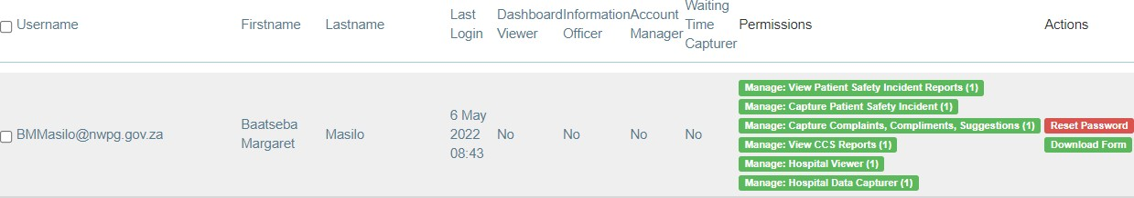

Figure 1: Upload of user account form

Provinces are responsible for managing their own user accounts and to set-up standardized processes for managing their user accounts. Therefore every Province issued a circular/standard operating procedure that guides staff on the procedure to request or amend user accounts.
Account managers can generate a User Account list that details the user accounts created for the provinces with the roles and org units assigned to every account as well as last login time, account created/terminated and whether the account is enabled (active), see Figure 2. The detailed procedure on how to create user accounts and generate the user account list is described in the National SOP to manage user accounts on the Ideal Health Facility Information System. This SOP also details the requirements to review all user account on an annual basis.
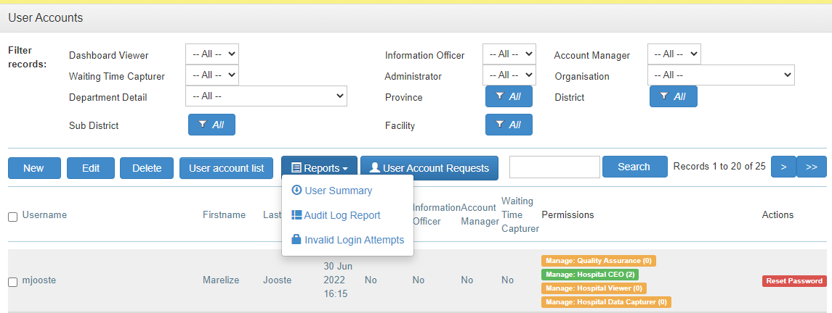
Figure 2: User account list and Audit log report

NDoH manages accounts requested by staff working at the NDoH and other outside organisations where applicable. User account forms must also be signed electronically by the user as well their supervisor. Where outside organisations requests access, the Chief Director: District Health services must give approval for the creation of the accounts (this is only applicable for the Ideal Clinic/CHC/hospital assessments). All account requests are submitted to the National administrator for creation/amendment.

Once an account has been created, an e-mail notification is sent to the user with the username and temporary password. Once the user has logged in, the user must select their own password. The password must have 8 characters, of which one is an uppercase letter, one lower case and one numerical number or special character. The system has an option where users can reset their password if they have forgotten it. This functionality is only functioning if the user’s account is enabled (accounts that are inactive for 3 months are automatically disabled).

All staff that has left the service or staff that no longer require access to the information system, must complete a user account form and select the option for ‘Termination’ and enter the date of termination of the user account. Once a user account form is uploaded for staff that has terminated their service, the system uses the date of termination filled in on the form to insert the date of termination on the ‘User Account List.’

An Audit Log Report is available that indicates the user who created/amended the account or who requested a password reset and the date of the amendment of the account, see Figure 2. The detailed procedure on how to generate the report is described in the National SOP to manage user accounts on the Ideal Health Facility Information System.

Roles and permissions for user accounts

There are seven types of roles that can be assigned to an account. See Table 1 that describes the functions of the roles.
Type of roles | Function of roles allows the user to:
View | - View the reporting and dashboard section
Capture | - Capture data
Authorise | - Applicable for hospital module where there is a role  to authorize as Quality Assurance manager of Chief Executive Officer.
Data Controller (Administrator) | - Re-open closed/resolved PSIs and Complaint forms  - Delete PSI and CCS forms.
Notifications contact manager | - Enable the user to set-up notifications for staff to receive an e-mail or SMS when a Severity Assessment Code  one PSI was logged on the system.
Account Manager | - Create and amend user accounts
Administrator | - Development, maintenance and security of the system
Table 1: Roles and functions of user accounts

Permissions are assigned for each role according to the specific level (facility, district, sub-district, provincial) requested on the user account form. Permission level can also be assigned according to the ‘ownership’ of the facilities, this only apply to user accounts created for Gauteng, KwaZulu- Natal and Western Cape that have facilities that is ‘owned’ by local government.

Maintenance and security of user accounts

User accounts that have not been accessed for three consecutive months is automatically disabled. Staff must complete a user account request form and select the option for ‘Reset’ password.

All passwords must be renewed/reset after three months. All users will automatically be directed to the page to reset their passwords once the three month period has been reached.

A report is available under the User Account functionality to track the number of invalid login attempts, see Figure 3 and Figure 4. Invalid login attempts are monitored continuously by the developers for possible hacking attempts.
Figure 3: Report drop-down for Invalid Login Attempts

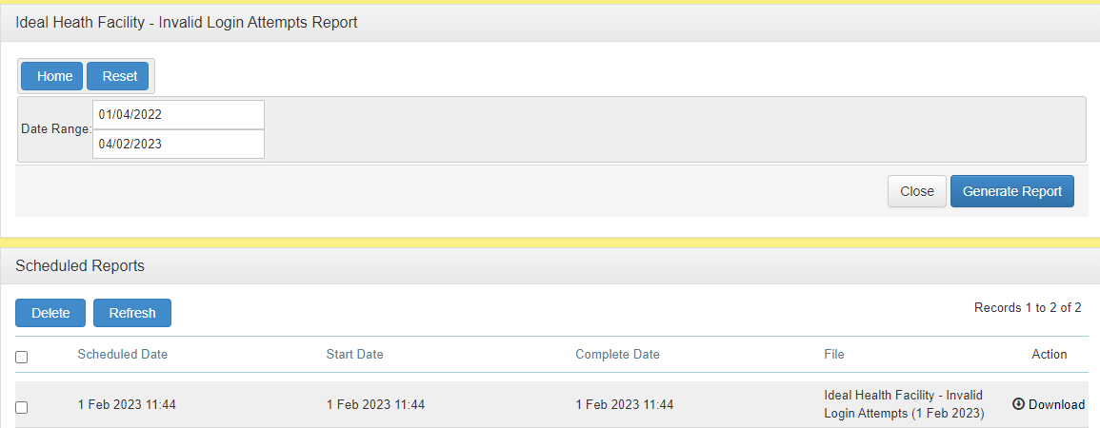
Figure 4: Generate Invalid Login Attempts report

Information system support to staff

Training guides are available to assist staff to capture data and generate reports and dashboards. The training guides can be downloaded under the ‘Data management’ tab of the website.

A test site is also available at https://test.idealhealthfacility.org.za/ that is used to train staff.

Help desk support is provided at idealclinic@health.gov.za

System support and change requests from NDoH to developers

System support and change requests from the NDoH to the developers of the information system is tracked by the Service provider using the Jira Service Management service (https://asgsolutions.atlassian.net/servicedesk/ ). NDoH log all requests for support and changes on the management tool. Once a request has been logged, a case number is assigned. Each case is tracked with a status of ‘In review’, ‘scheduled’, ‘In progress’, ‘resolved’ and ‘closed’ to ensure that the NDoH can keep track of all requests made. See Figure 5, screenshot example of support desk to log change requests.
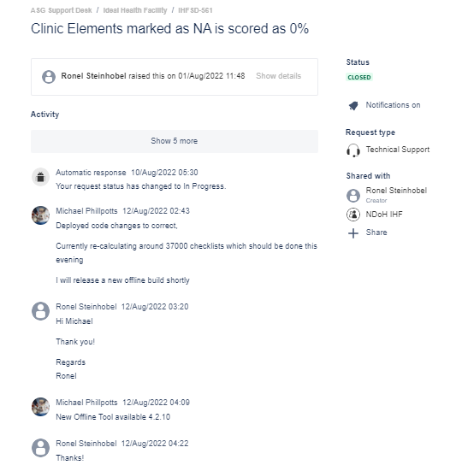
Figure 5: Screenshot of support desk

A worklog of all cases logged and status of each case can be generated from Jira, see Figure 6 for an example. Change requests are first published on the test site (https://test.idealhealthfacility.org.za/ ) for review by NDoH before it is published on the live/production site.
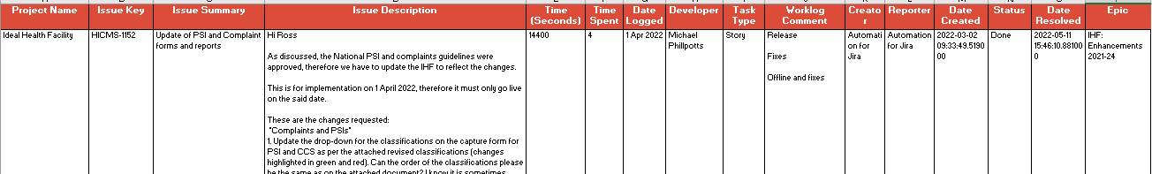
Figure 6: Example of a worklog

Back-up procedure

SQL Transactional Backup:
- The SQL database will be backed up every 15 minutes to ensure minimal data loss in case of any disaster.
- The transactional backup will be stored on a designated local storage.
Onsite Full Backup:
- A full backup of all data will be performed every day and stored on a designated local storage.
- The onsite full backup will be automatically run daily.
Offsite Full Backup:
A full backup of all data will be performed every day and transferred securely using SFTP to an offsite location.
- The offsite full backup will be automatically run daily.
- The offsite backup will be stored for 30 days to meet the requirement for data retention.
- Access to the offsite backup will be restricted to authorized personnel only.
Offsite Full Cloud Backup:
- A monthly full backup of all data is transferred securely to an Azure Blob Storage account (South Africa North)
- The backup will be stored for 13 months.
- Access to the offsite backup will be restricted to authorized personnel only.

Intellectual Property

Intellectual property is the sole and exclusive property of the NDoH. Foreground Intellectual Property (e.g. M&E data collection templates and resultant data interpretations) also belongs to the NDoH. Background Intellectual property contained in the Service Provider’s source code will remain the property of the Service Provider, with NDoH having rights to use this intellectual property for as long as Maintenance fees are paid. Should the NDoH exercise its right not to renew the service level agreement at the end of term, the Service Provider will provide the NDoH with the latest copy of the source code and associated data base(s) for its own use. The Service Provider will provide no further warrantee for the software thereafter.

Confidentiality of data

Data containing patient information will not be published in accordance with the Promotion of Access to Information Act, 2000 (Act No. 2 of 2000) (PAIA) and the Protection of Personal Information Act, 2013 (Act 4 of 2013). PAIA gives effect to the constitutional right of access to any information held by the state and any information held by any other person, provided that such information is required for the exercise or protection of any rights. The Protection of Personal Information give effect to the constitutional right to privacy, by safeguarding personal information when processed by a responsible party, subject to justifiable limitations that are aimed at:
- balancing the right to privacy against other rights, particularly the right of access to information; and
- protecting important interests, including the free flow of information within the Republic and across international borders.

It is only the PSI and Complaints, compliments and suggestion modules that contains patient information. The fields for name and surname of patient in the PSI module are not mandatory fields as anonymizing the data is encouraged. The field for patient file is compulsory to complete and is used and the patient identifier.

Annexure A: Ideal Health Facility - User Registration Form


