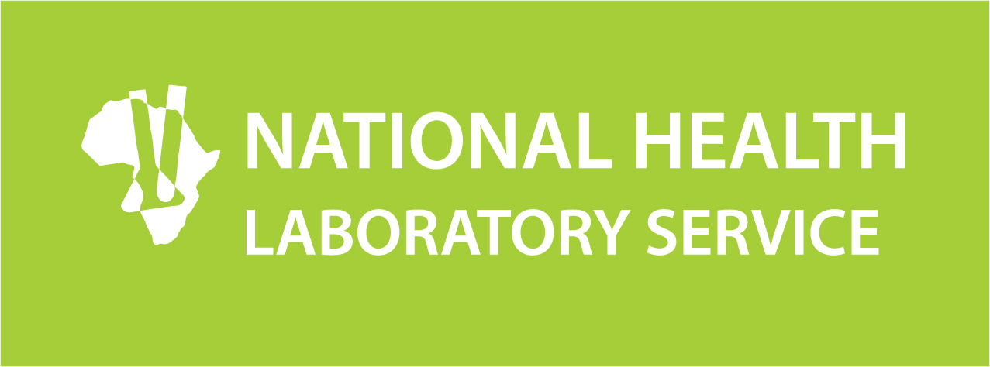

PHC LABORATORY TOOLKIT TRAINING

PROGRAMME

SECTION |  | TIME
Welcome |  | 09:00 – 09:15
Session 1 | Background and Rationale | 09:15 – 10:00
Tea |  | 10:00 – 10:15
Session 2 | Primary Health Care Laboratory Tool | 10:15 – 13:00
Lunch |  | 13:00 – 13:30
Session 3 | Roles and Responsibility | 13:30 – 14:15
Session 4 | Practical Session (completion of Worksheets) | 14:14 – 15:00
Session 5 | Way forward and Closure | 14:30 – 15:00

